CN ASSIGNMENT 6

Q1. To configure and verify routing using RIP Version 2 protocol in a network.
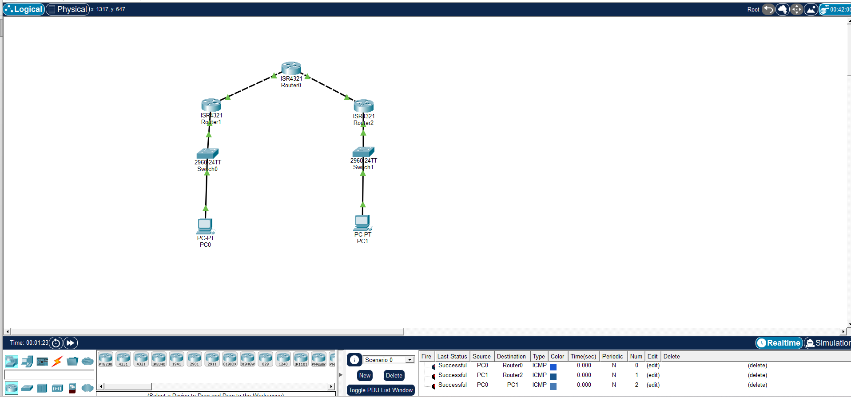
Commands for Router 1
enable
conf t
interface gig0/0/0
ip address 100.1.1.2 255.255.255.0
clock rate 64000
no shutdown
interface gig0/0/1
ip address 20.1.1.1 255.255.255.0
no shutdown
router rip version 2
no auto-summary
network 100.1.1.0
network 20.1.1.0
end
Commands for Router 2
enable
conf t
interface gig0/0/0
ip address 100.1.1.1 255.255.255.0
no shutdown
interface gig0/0/1
ip address 172.16.2.1 255.255.0.0
no shutdown
router rip version 2
no auto-summary
network 100.1.1.0
network 172.16.0.0
end
Commands for Router 3
enable
conf t
interface gig0/0/0
ip address 20.1.1.2 255.255.255.0
no shutdown
interface gig0/0/1
ip address 10.2.2.1 255.255.255.0
no shutdown
router rip version 2
no auto-summary
network 20.1.1.0
network 10.2.2.0
end

